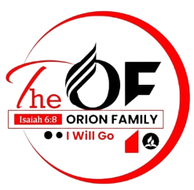

**SEVENTH-DAY ADVENTIST CHURCH**

**THE ORION FAMILY**

**Email:** [**theorionfamilyofficial@gmail.com**](mailto:theorionfamilyofficial@gmail.com) **Tel: 0100188123/ 0794692015**

……………………………………………………………………………………………………………………………………………………………………………….

To: Heavenly Echoes Ministers

Dear Sir/Madam

**RE: Invitation to The Orion Family Launch on 15th September 2024.**

Greetings in the name of Jesus Christ, our Lord and Savior. I hope this message finds you well and thriving in your faith. It is with great joy and pleasure that The Orion Family, extend this heartfelt invitation to you for our launch event on **15th September 2024** at **Thika Central SDA Church**, from 8:00 a.m. to 6:00 p.m.

This event is dedicated to sharing our music ministry with fellow Ministers and raising funds to support our ministerial efforts. Your presence and support will mean a great deal to us.

To help us in planning and making the necessary arrangements, we kindly ask that you confirm your attendance before **11th August 2024.** Your prompt response will greatly assist us in ensuring that the event runs smoothly and that everyone is accommodated comfortably.

May God bless you abundantly and keep you in His grace.

With warm regards,

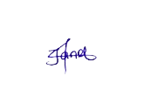Benjamin Nemwel Janet Kimayu Gathoni Nancy

Chairperson………….. Secretary……………. MusicDirector………….